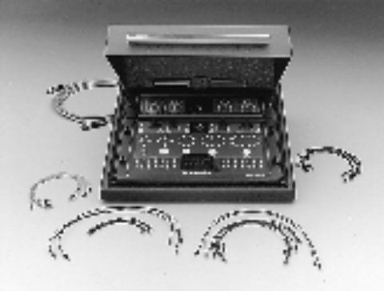
Model 8006 Component Test Fixture
The Model 8006 Component Test Fixture was designed specifically for making sensitive measurements on standard package devices with minimal setup time. Individual components may be connected to one of eight device sockets, including axial, 4-, 8-, 10-, and 12-lead T0, and 28-pin DIPs. Instrumentation can be easily integrated through the 3-lug triax, BNC, or binding post connectors on the rear panel.
Signals from the test instruments are accessible at the test fixture’s front panel. Mini jumper cables are provided to connect the signal to the appropriate device socket, which is also located on the front panel. This unique patch-board design allows for maximum versatility and the fastest possible setup times.
The 8006 Test Fixture maintains accuracy throughout the test circuit with greater than 100TΩ
(1014Ω) path isolation, 4-wire connections, guarded jumpers, gold contacts and interconnects, and less than 100fA offset current. A hinged lid covers the component panel to provide a light-tight and shielded measurement.

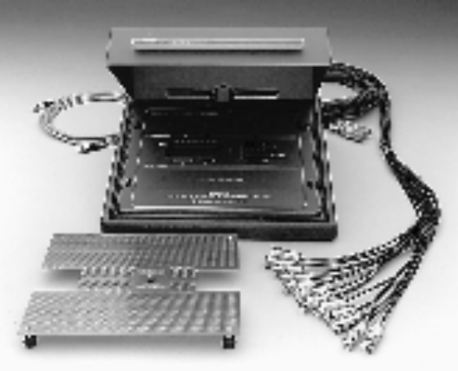
Model 8007 Semiconductor Test Fixture
The 8007 Semiconductor Test Fixture assures accurate measurement data for DC characterization of packaged devices. This test fixture provides a convenient means of making sensitive measurements on Dual In-line Packages (DIPs) of 0.3 or 0.6 inch centers and up to 48 pins with the 24- or 48-pin socket. The prototyping board can be installed on the front panel for customized testing of packages with up to 72 pins. Accuracy is maintained to the DUT with isolation of more than 1TΩ. Offset current for the 8007 is less than 1pA, while maximum signal voltage is 200V with 1A peak current. A hinged cover provides light-tight and shielded measurements. 72 ferrite beads are also included for custom applications when DC tests are performed on active devices and some decoupling is required.
Supplied with interlock cable, phototyping
board, and two input cables (each terminated
with twelve 3-slot triax plugs).

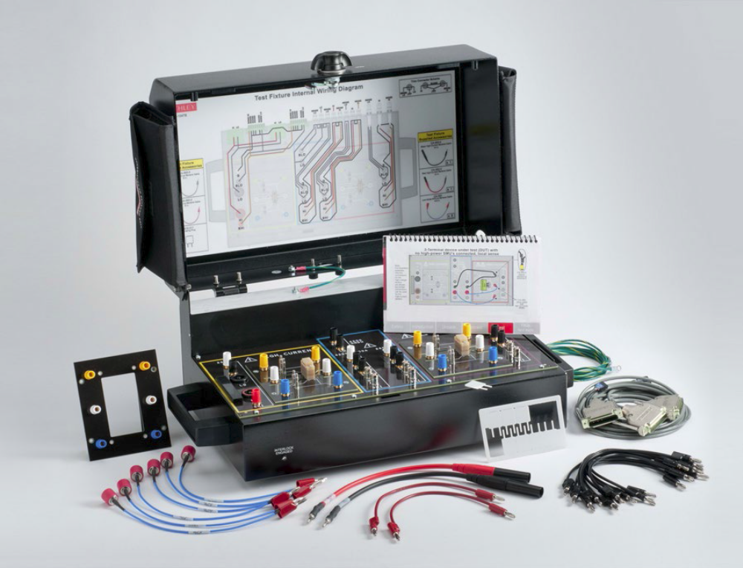
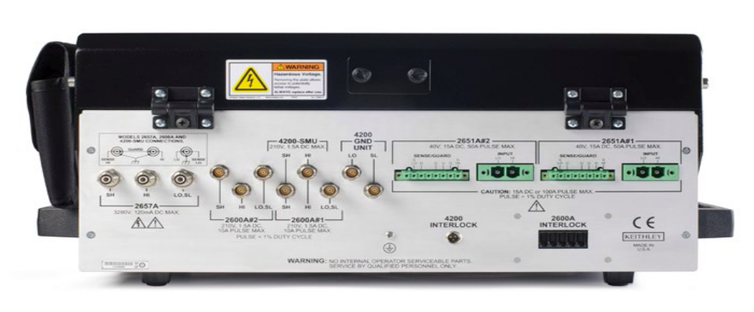
Вид задней панели
Model 8010 High Power Device Test Fixture
ACCESSORIES SUPPLIED
3 ea. CA-558-2 Three-Pin Interlock Connector Cables (2m)  12 ea CA-560-x Banana to Banana Jumper Cables (203mm)  2 ea. CA-562-x Safety Banana to Banana Jumper Cables  (254mm)  6 ea. CA-563 BNC to Banana cables (241mm)  2 ea. CA-568-120 Earth Safety Ground Cables (305cm) | 1 ea. 8010-317 Socket Insulating Plug Card  1 ea. 8010-CTB Customizable Test Board  2 ea. 8010-DTB Device Test Board for TO-247 Devices  (3kV, 100A)  For use with: 2651A, 2657A, 4200-  SCS, 26xxB, 2600-PCT-x, 4200-PCT-x

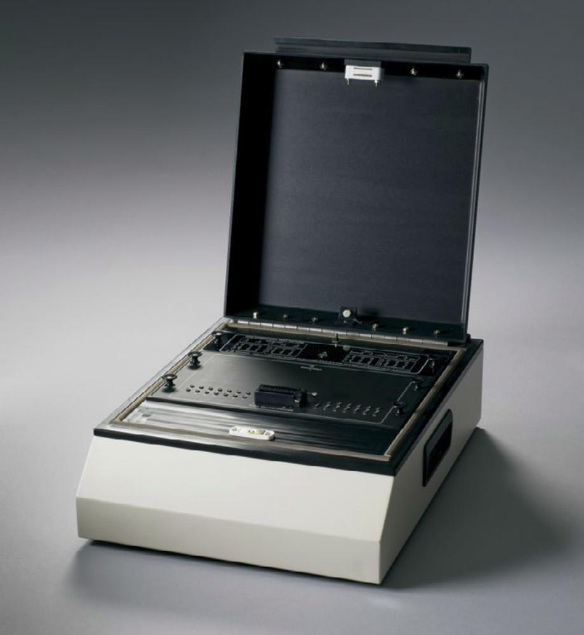

Model LR:8028: Component test fixture optimized for device testing up to 200V/1A. Includes color-coded mini jumpers for easy device connections.

ACCESSORIES SUPPLIED:
40 ea. standard color-coded Teflonｮ mini jumpers, 20 red and 20 black
LR:8028 Instruction Manual
For use with: 4200-SCS, Series 2600B, 6482,
any 40V rated triaxial or SMA instrument

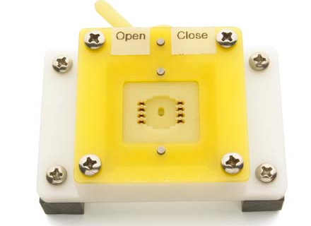

https://yandex.by/images/search?source=wiz&img_url=http%3A%2F%2Fwww.coda-systems.co.uk%2Fcatalog%2FKWC3-lg.jpg&text=component%20test%20fixture%208007&noreask=1&pos=2&lr=157&rpt=simage
http://www.promoco.se/wp-content/uploads/2012/12/ManualTestFixtures.png

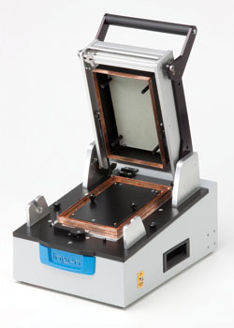
http://orbis.com.ru/sites/default/files/images/ingun_rf-suojattu_fixture.jpg

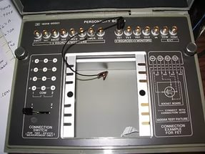

https://im1-tub-by.yandex.net/i?id=73ae517f2d29ba515ec56ac19a967e7c&n=33&h=215&w=287

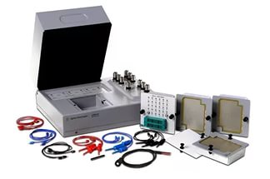
https://im0-tub-by.yandex.net/i?id=b3fab3f2ee581e09ba0713bfeeabbaa9&n=33&h=215&w=324

